# In Class

## Problem Statement

Generate a random sample of size 20 from N(2,1). Calculate the CI of the median using

1. Standard
2. Boot Percentile
3. Boot T

Then run each of them 100 times, and calculate the coverage each method provides.

## Code

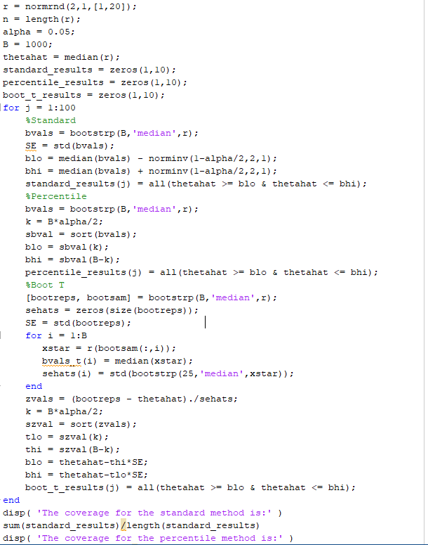

## Results

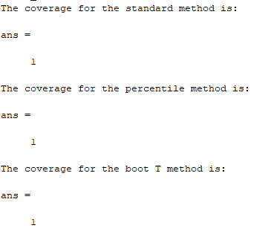

## Discussion

All three methods generated a coverage of 100%. The estimated median from the data was always within the confidence intervals generated by the three procedures. This was validated several times.

# Problem 7.4

## Problem Statement:

Using the same value for the sample mean, repeat Example 6.3 for different sample sizes of . What happens to the curve showing the power as a function of the true mean as the sample size changes?

## Code

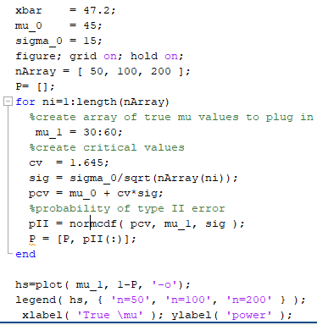

## Plot

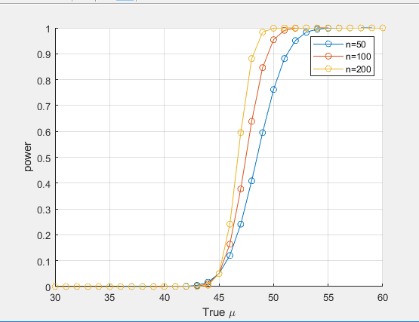

## Discussion

As we increase the sample size we increase the power of our tests. This is to be expected as the variance of the sample mean decreases as we increase our sample size. A smaller variance will increase our tests ability to avoid type II errors, thus our power increases.

# Problem 7.5

## Problem Statement:

Repeat example 7.6 using a two-tail test. Test for the alternative hypothesis that the mean is not equal to 454.

## Code:

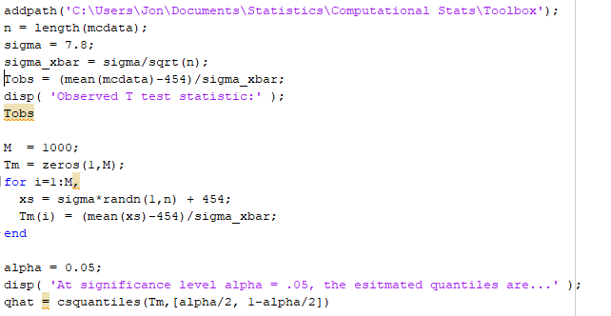

## Output

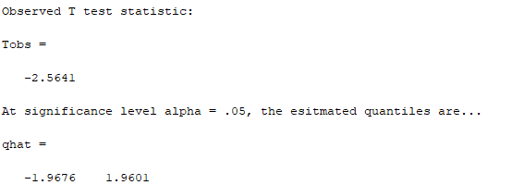

## Discussion

We are interested in the hypothesis

H0: Mu = 454

H1: Mu != 454

We will perform this two-tailed test by Monte Carlo simulation. We calculate the T test statistics with our data. To test this we use Monte Carlo simulation to generate data under the null hypothesis. We now have M sample T values with which we can construct a 95% confidence interval. The output above shows both our observed T statistic, and the confidence interval generated by our simulation. Our observed value is outside of the interval, so we reject the null hypothesis.

# Problem 7.7

Write matlab code that implements the parametric bootstrap. Test it using the forearm data.